### Grammar Management

#### Use case diagram

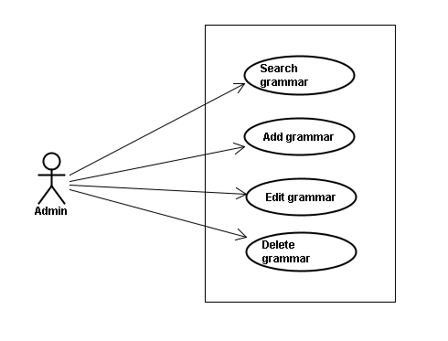

#### Use case specifications

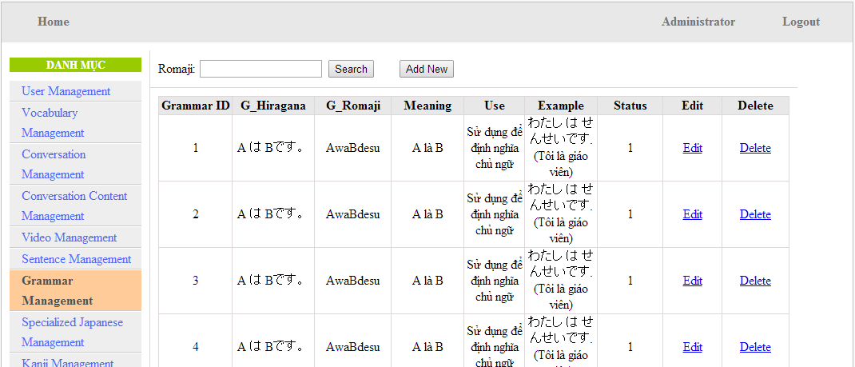

Screen Description: This is Grammar Management screen. When admin want to do work with grammar database, admin have to log in. At here, Admin can manage grammar database by search grammatical structure, add new grammatical structure, edit grammatical structure and delete grammatical structure.

##### UC0028: <Admin> Search grammar

Search grammar screen:

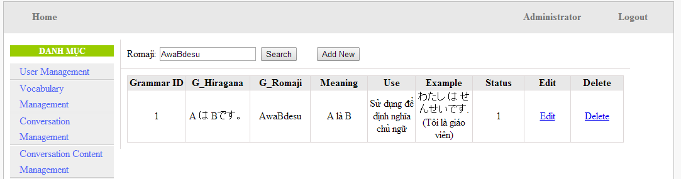

|  |  |  |  |  |
| --- | --- | --- | --- | --- |
| **UC0028 - Specification** | | | | |
| **Use-case No.** | <UC0028> | **Use-case Version** | | <1.0> |
| **Use-case Name** | Search grammar | | | |
| **Author** | Minh PT | | | |
| **Date** | 09/06/2014 | **Priority** | <High > | |
| **Actor:**  Admin  **Summary:**  When Administrator wants to search a grammatical structure in database, Admin can input a grammatical structure by “romaji” letter then click button “Search”. If that grammatical structure is existed, system will return meaning.  **Triggers**  Click on “Grammar management” tab, input grammatical structure in the right text box then click “Search” button  **Preconditions:**   * Website is available * User has to login as Administrator * User has to input data in search area   **Post Conditions:**  Display detail information of grammatical structure  **Main Success Scenario:**   |  |  |  | | --- | --- | --- | | **Step** | **User** | **System** | | 1 | Have logged into system as an admin |  | | 2 | Click on “Grammar management” tab | Displays criteria search screen | | 3 | Fill information of the grammatical structure that they want to find into these fields then click “Search” button | Displays search result as a table with these elements:   * Grammar ID * G_Hiragana * G_Romaji * Meaning * Use * Example * Status * Edit * Delete |     **Alternative Scenario:**   |  |  |  | | --- | --- | --- | | **At Step** | **User** | **System** | | 3 | Fill information of the grammatical structure that they want to find into these fields then click on another link | Switch to selected page |   **Exceptions:**   |  |  |  | | --- | --- | --- | | **At Step** | **User** | **System** | | 3 | Fill information of the grammatical structure that they want to find (that do not exited in database) into these fields then click “Search” button | Return Error message to inform that grammatical structure cannot be found | | | | | |